**Lab 5**

**Test Cases:**

|  |  |  |  |  |  |  |
| --- | --- | --- | --- | --- | --- | --- |
| **Test Case ID** | **Test Case Description** | **Test Steps** | **Test Data** | **Expected Results** | **Actual Results** | **Pass/Fail** |
| TU01 | check system behavior if there’s no mode | 1. User enter the number of students 2. user enters test scores of students 3. press enter | number of student: 4  test score#1: 88  test score#2: 45  test score#3: 77  test score#4: 98 | The system should return null because there is no mode | Not As Expected | Fail |
| TU02 | ensure that elements entered are sorted in ascending order to calculate mean, median, and mode | 1. User enter the number of students 2. user enters test scores of students 3. press enter | number of student: 8  test score#1: 88.8  test score#2: 45  test score#3: 77  test score#4: 98  test score#5: 5  test score#6: 63  test score#7: 100  test score#8: 44 | System should return the numbers order from smallest to largest | As Expected | Pass |
| TU03 | Check mode result when there is one mode in test scores | 1. User enter the number of students 2. user enters test scores of students 3. press enter | number of student: 5  test score#1: 88  test score#2: 78  test score#3: 95  test score#4: 40  test score#5: 95 | Calculated mode should be the most frequent | As Expected | Pass |
| TU04 | check behavior of system when number of students is zero | 1. User enter the number of students 2. user enters test scores of students 3. press enter | number of student: 0 | Exception occurs | As Expected | Pass |
| TU05 | Check mean result of test scores is calculated correctly | 1. User enter the number of students 2. user enters test scores of students 3. press enter | number of student: 4  test score#1: 30  test score#2: 10  test score#3: 40  test score#4: 20 | System should return the mean result of the student test scores correctly | As Expected | Pass |
| TU06 | Check median result when The number of student is odd is correct | 1. User enter the number of students 2. user enters test scores of students 3. press enter | number of student: 5  test score#1: 10  test score#2: 20  test score#3: 50  test score#4: 90  test score#5: 100 | System should return the median of the student  test scores | As Expected | Pass |
| TU07 | Check median result when The number of student is even is correct | 1. User enter the number of students 2. user enters test scores of students 3. press enter | number of student: 5  test score#1: 10  test score#2: 20  test score#3: 50  test score#4: 80  test score#5: 90  test score#6: 100 | System should calculate the median of the student  test scores accurately | As Expected | Pass |

**Original java Class & Test Class:**



**Test Result:**

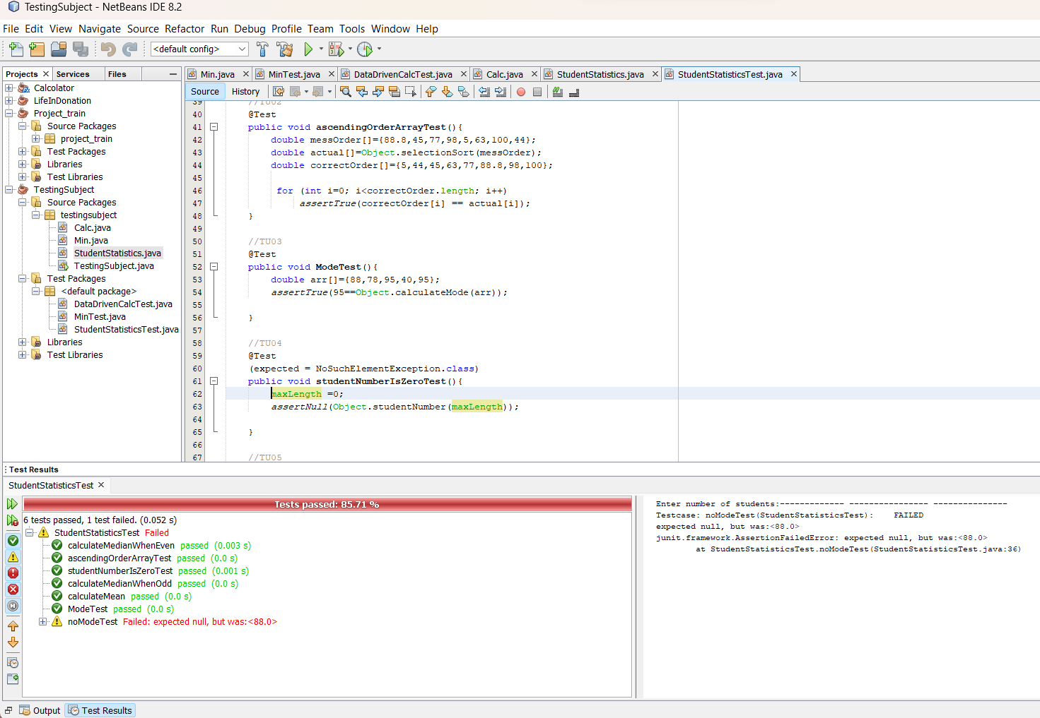

|  |  |  |
| --- | --- | --- |
| **Name** | **ID** | **Class** |
| Razan Abdulsalam Alzahrani | 2112107 | C8L |
| Laila Najem Alzahrani | 2110808 |